Travelling in Greater Manchester
Greater Manchester is made up of ten towns and cities in North West England: Bolton, Bury, Oldham, Manchester, Rochdale, Salford, Stockport, Tameside, Trafford and Wigan.
As a region, Greater Manchester has a large, well-connected transport network. There are multiple different ways to get around the region including by tram, bus or rail as well as there being good cycling and walking links. It is well connected and below we explain the different travel options available to you.

Metrolink
Metrolink is Manchester’s tram system and it runs across seven of the ten Greater Manchester towns and cities. There are 99 stops on the network, with services operating a high frequency across all lines.
During the week and on Saturdays, Metrolink runs from 6am until midnight, while on Sundays, it runs from 7am until 11pm.
Transferring between tram lines is easy to do, especially as most of the routes intersect at various points.
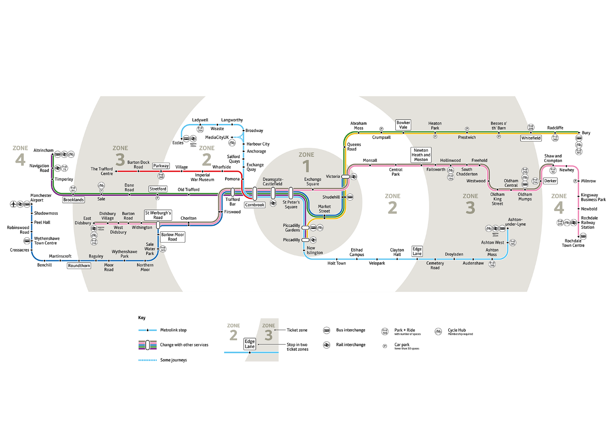
How to buy a ticket
There are many different ways to buy a ticket and ticket prices are determined by the zone(s) you are travelling through/to, it does not cost anything additional to change lines if required.
Options to purchase a ticket include:
- TfGM travelshop – You can visit one of the TfGM travelshops to get travel advice or to pay for a ticket by cash or card (see below for further information).

- get me there smart card - You can buy a range of tickets and travelcards, including bus, tram and train passes, online at getmethere.com and store them on a smart card.
Using a get me there account is perfect if you want to buy a day ticket or season ticket in advance using a computer, tablet or smartphone. You can buy a ticket up to 7 days in advance and your ticket will be available from the day after you buy it. Just use a smart reader at a tram stop to load and activate. When you create your account, you can request a get me there card or link another compatible smart card, such as a concessionary card you already have (see page XX for young people, over 66 and disability concessions).
- Contactless pay as you go - If you are travelling for a single journey or for multiple journeys in one day or across a week, you can pay as you go by touching in and touching out at a smart reader on-stop using your contactless payment card or device. We’ll work out the adult single or travelcard prices for your journeys, up to a daily and weekly cap.

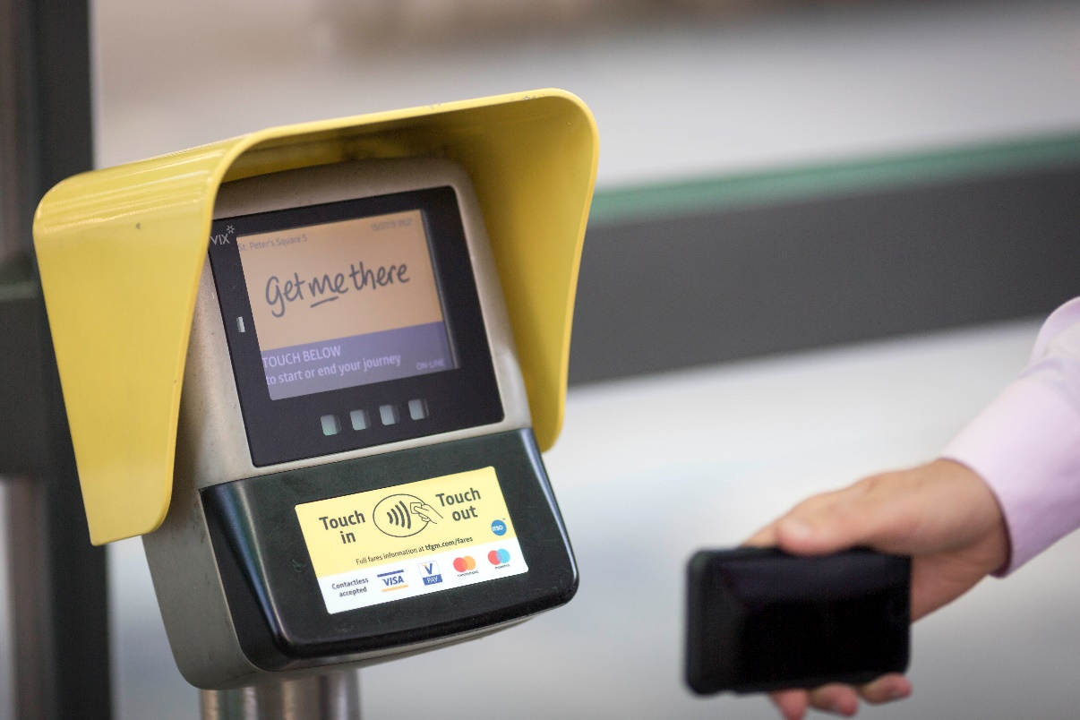

- get me there mobile app - There's no need to buy a printed ticket, just use your phone or tablet to download the get me there app to buy weekend, 7-day and 28-day travelcards for Metrolink trams.

- Ticket machines at tram stops - pay by credit or debit card (including contactless) or by cash (change given) for adult, child, concession and family tram tickets.
Please note - You cannot pay for a journey on the tram, and you must have a ticket before you get on.
All Metrolink trams and its tram stops are wheelchair accessible.
Further information including a map of the Metrolink network and ticket prices can be found at tfgm.com/metrolink.

Rail
There is an extensive rail network, connecting all of Greater Manchester and surrounding areas.
In Manchester city centre, there are three main stations; Piccadilly (the largest), Victoria and Oxford Road. Services run to other areas and cities across the country, throughout the day, by a number of different rail operators.
How to buy a ticket
Depending on where and when you are travelling, it may be cheaper to purchase a ticket in advance. There are several different varieties of ticket.
You can pay for your ticket:
- At the rail station ay by cash or card at the ticket office or ticket machines. If you can't buy a ticket at the station, you can pay for most tickets on the train by cash or card.
- Online - Buy individual rail journey tickets, season tickets and combined tickets on rail company websites or smartphone apps. Select your ticket on the National Rail journey planner, then follow the links to buy online.
Advance tickets are valid for a specific time and service only. There are also off-peak tickets, which are valid for travel on any service after 9.30am, or anytime tickets which are valid for any service throughout the day.
You can find full details of services at nationalrail.co.uk.

Bus
Greater Manchester’s bus network is extremely extensive and covers all ten districts.
Services operate from early in the morning until late at night.
Bus services are operated by different bus companies, so depending on which service you are planning to use, and how regularly, this will determine which ticket is best suited for you.
How to buy a ticket
You can pay for your ticket:
- On board – using cash or contactless.
- Online – using your smartphone or via the operator app, alternatively you can add products to a smart card via getmethere.com or the operator website.
- TfGM travelshop– You can visit one of the TfGM travelshops to get travel advice or to pay for a ticket by cash or card (see below for further information).
Information on the different bus companies which operate in Greater Manchester, and their ticketing, can be found at tfgm.com/bus.

Cycling and Walking
In Greater Manchester, we are connecting up every area and community to make it easier and safer for people to travel on foot or by bike for everyday trips.
There is a cycle hire scheme in the region, with hire bikes now available from multiple stations along Oxford Road, MediaCity and at the University of Salford. The scheme will be expanding later this year with more bikes and more stations.
There are also various ‘bike library’ schemes across Greater Manchester where you are able to borrow a bike and sign up to free cycling lessons.
More information about these various schemes can be found at beeactive.tfgm.com.

TfGM Travelshops
Buy a wide range of tickets for buses, trains and trams, including tickets for students and young people. You’ll find System One travelcards for all-day, weekend, 7-day, 28-day, or annual travel, Metrolink tram season tickets, Wayfarer tickets, and National Express coach tickets. You can find a travelshop near you by visiting: www.tfgm.com/travelshops

Coach services
Coach travel offers a convenient and cheap way to travel between cities and across longer distances. A number of private coach operators serve the region.
The main departure point for coach services is from Chorlton Street Coach Station in Manchester city centre.
National Express is the largest coach company in the UK and you can find information on prices and timetables at www.nationalexpress.com.
Megabus also offer cheap coach travel between major cities in the UK. More information can be found at https://uk.megabus.com.

Concessions and discounts
If you are a Ukrainian refugee living with a host family or relative in Greater Manchester you could be entitled to one of the following concessions or discounts:
Children
Children under 5 travel free on buses, trains and trams in Greater Manchester. When they reach the age of 5 they must pay the child fare.
Young people
iGo
From the age of 5-16, you will require an iGo to purchase child tickets on buses and trams . An iGo card costs £10 and lasts until 31 August after your 16th birthday.
You can also buy TfGM schools weekly ticket and 10 trip carnet (available on school bus services only), smart versions of System One Junior, AnyBus tickets and some tickets sold by individual bus companies.
To be eligible for an iGo you need to be:
- Living in Greater Manchester
- Between the age of 5 and 16.
Our Pass
For young people aged between 16-18, the pass entitles holders to free travel on local bus services across Greater Manchester and they can also buy off-peak 1-day and weekend travelcards for the tram (Metrolink) at half adult prices.
To be eligible for an Our Pass you need to be:
- Living in Greater Manchester
- Between the age of 16 and 18.

Older persons travel pass
Travel for free on all buses within Greater Manchester between 9.30am and midnight, Monday to Friday, and all day at weekends and on public holidays.
You can also choose to pay £10 to add tram and train to your pass, for a year’s unlimited off-peak travel on Metrolink and trains within Greater Manchester. You can then travel on Metrolink trams and in trains after 9.30am on Monday to Friday, and all day on weekends and public holidays.
To get a travel pass for older people from TfGM you must:
- Be aged 66 or over
- Be living in Greater Manchester, (if you live outside Greater Manchester, you can apply for a pass in your own area but you cannot add tram and train travel within Greater Manchester to passes issued by other areas).

Travel pass for disabled people
If you are disabled, you could be eligible for a pass that gives you free and low-cost travel in Greater Manchester and the rest of England under the English National Concessionary Travel Scheme. Depending on your disability, you could qualify for either a travel pass for disabled people or a travel plus pass for disabled people.
Visit tfgm.com/passes-for-disabled-people or email ukrainesupport@tfgm.com to check if you are eligible.
How to apply
If you would like to apply for any of these schemes, please email ukrainesupport@tfgm.com with:
- the scheme you are applying for
- the address you are residing at in Greater Manchester
- if you are part of the ‘Homes for Ukraine Scheme’ or staying with a relative.
The team will support you through the application process.

